**Integrating the Healthcare Enterprise**



**IHE QRPH**

**Technical Framework Supplement**

**Quality Measure Execution – Early Hearing**

**(QME-EH CP2015)**

**QRPH**

**Draft in preparation for Public Comment**

Date: 03/04/2015

Author: Lisa R. Nelson

Email: Lisa.Nelson@LantanaGroup.com

**Foreword**

This is a supplement to the IHE <Domain Name> Technical Framework <VX.X>. Each supplement undergoes a process of public comment and trial implementation before being incorporated into the volumes of the Technical Frameworks.

*<For Public Comment:>* This supplement is published on <Month XX, 201x> for Public Comment. Comments are invited and may be submitted at [http://www.ihe.net/<domain>/<domain>comments.cfm](http://www.ihe.net/Technical_Framework/public_comment.cfm). In order to be considered in development of the Trial Implementation version of the supplement, comments must be received by <Month XX, 201X>.

*<For Trial Implementation:>* This supplement is published on <Month XX, 201X> for Trial Implementation and may be available for testing at subsequent IHE Connectathons. The supplement may be amended based on the results of testing. Following successful testing it will be incorporated into the <Domain Name> Technical Framework. Comments are invited and may be submitted at [http://www.ihe.net/<domain>/<domain>comments.cfm](http://www.ihe.net/%3cdomain%3e/%3cdomain%3ecomments.cfm).

This supplement describes changes to the existing technical framework documents.

“Boxed” instructions like the sample below indicate to the Volume Editor how to integrate the relevant section(s) into the relevant Technical Framework volume.

Amend section X.X by the following:

Where the amendment adds text, make the added text bold underline. Where the amendment removes text, make the removed text bold strikethrough. When entire new sections are added, introduce with editor’s instructions to “add new text” or similar, which for readability are not bolded or underlined.

General information about IHE can be found at: [www.ihe.net](http://www.ihe.net).

Information about the IHE <Domain Name> domain can be found at: <http://www.ihe.net/Domains/index.cfm>.

Information about the organization of IHE Technical Frameworks and Supplements and the process used to create them can be found at: <http://www.ihe.net/About/process.cfm> and <http://www.ihe.net/profiles/index.cfm>.

The current version of the IHE <Domain name>Technical Framework can be found at: <http://www.ihe.net/Technical_Framework/index.cfm>.

*<Comments may be submitted on IHE Technical Framework templates any time at* [*http://ihe.net/ihetemplates.cfm*](http://ihe.net/ihetemplates.cfm)*. Please enter comments/issues as soon as they are found. Do not wait until a future review cycle is announced.*

CONTENTS

Introduction to this Supplement 6

Open Issues and Questions 6

Closed Issues 7

General Introduction 9

Appendix A - Actor Summary Definitions 9

Appendix B - Transaction Summary Definitions 9

Glossary 10

Volume 1 – Profiles 11

<*Copyright Licenses>* 11

<*Domain-specific additions>* 11

X Quality Measure Execution-Early Hearing (QME-EH) – Content Profile 12

X.1 Actors, Transactions, and Content Modules 12

X.1.1 Actor Descriptions and Actor Profile Requirements 14

X.1.1.1 Report Assembler 14

X.1.1.2 Content Consumer 15

X.1.1.3 Content Creator 16

X.2 Actor Options 16

X.2.1 Assemble ALQR Option 16

X.2.2 Assemble PLQR Option 17

X.2.3 Assemble ALQR from PLQR Option 17

X.2.4 Assemble PLQR from SoCD Option 17

X.2.5 Consume ALQR Option 17

X.2.6 Consume PLQR Option 17

X.2.7 Create SoCD Option 17

X.3 Required Actor Groupings 19

X.4 Overview 19

X.4.1 Concepts 19

X.4.2 Use Cases 20

X.4.2.1 Use Case #1: Low Transparency for Receivers, High Burden for Senders 20

X.4.2.1.1 Use Case Description 20

X.4.2.1.1.1 Pre-conditions 20

X.4.2.1.1.2 Main Flow 21

X.4.2.1.1.3 Post-conditions 21

X.4.2.1.2 Processing Steps 21

X.4.2.1.3 Process Flow 21

X.4.2.2 Use Case #2: Better Transparency for Receivers, But Similar Burden for Senders 23

X.4.2.2.1 Use Case Description 23

X.4.2.2.1.1 Pre-conditions 23

X.4.2.2.1.2 Main Flow 24

X.4.2.2.1.3 Post-conditions 24

X.4.2.2.2 Processing Steps 24

X.4.2.2.3 Process Flow 24

X.4.2.3 Use Case #3: Less Burden For Senders AND Better Transparency For Receivers 26

X.4.2.3.1 Use Case Description 26

X.4.2.3.1.1 Pre-conditions 27

X.4.2.3.1.2 Main Flow 27

X.4.2.3.1.3 Post-conditions 27

X.4.2.3.2 Processing Steps 27

X.4.2.3.3 Process Flow 28

X.4.2.4 Use Case #4: Less Burden for Senders AND Receivers 29

X.4.2.4.1 Use Case Description 29

X.4.2.4.1.1 Pre-conditions 31

X.4.2.4.1.2 Main Flow 31

X.4.2.4.1.3 Post-conditions 31

X.4.2.4.2 Processing Steps 31

X.4.2.4.3 Process Flow 33

X.4.2.5 Use Case #5: Less Burden for Senders AND Standards-based Processing for Receivers 34

X.4.2.5.1 Use Case Description 34

X.4.2.5.1.1 Pre-conditions 35

X.4.2.5.1.2 Main Flow 35

X.4.2.5.1.3 Post-conditions 35

X.4.2.5.2 Processing Steps 35

X.4.2.5.3 Process Flow 36

X.5 Security Considerations 37

X.6 Cross Profile Considerations 37

X.6.1 Cross Enterprise Document Sharing (XDS.b), Cross Enterprise Document Media Interchange (XDM), or Cross Enterprise Document Reliable Interchange (XDR) 37

X.6.2 Sharing Value Set (SVS) 38

X.6.3 Newborn Admission Notification Information (NANI) 38

Appendices 39

Appendix A – New Actors 40

A.1 Brief Actor Definitions for New Actors 40

Appendix B – New Transactions 41

B.1Brief Transaction Definitions 41

Appendix C – Quality Measure Definitions 42

A.1 US Newborn Hearing Screening (EH_CMS31v4_NQF1354) 42

Appendix D – Data Element Concepts 46

D.1 Data Element Concepts 46

Volume 2 – Transactions 51

Volume 3 – UV Content Module Definitions 52

5. Namespaces and Vocabularies 53

6. UV Realm Content Modules 55

6.3.1 CDA Document Content Modules 55

6.3.1.Dx <Content Module Name (Acronym)> Document Content Module 55

6.3.1.Dx.1 Format Code 55

6.3.1.Dx.2 Parent Template(s) 55

6.3.1.Dx.3 Referenced Standards 55

6.3.1.Dx.4 Key Data Elements 55

6.3.2 CDA Header Content Modules 56

6.3.2.Hx <Header Element Module Name> Header Content Module 56

6.3.3 CDA Section Content Modules 56

6.3.3.Sx <Section Module Name> - Section Content Module 56

6.3.4 CDA Entry Content Modules 56

6.3.4.Ex <Entry Content Module Name> Entry Content Module 56

6.4 Section not applicable 56

6.5 <Domain Acronym> Value Sets 56

6.5.Vx <Value Set Name> <oid> 56

6.6 <Domain Acronym> Concept Domains 56

6.6.Cx <Concept Domain Name> <oid> 56

6.7 <Domain Acronym> Derivation Rules 56

6.7.Rx <Derivation Rule Set Name> Derivation Rule Set 57

6.7.Rx.1 <Data Element Name> Derivation Rule 57

Appendices 58

Appendix A – Volume 3 Namespace Additions 58

A.1 sdtc namespace 58

A.2 ihe namespace 58

Appendix B – <Appendix B Title> 58

B.1 <Add Title> 58

Volume 4 – National Extensions 59

7 National Extensions 59

7.I1 US National Extension 59

7.I1.1 Comment Submission 59

7.I1.2 US CDA Content Modules 59

7.I1.2.D1 QME-EH Summary of Care Document Specification 59

7.I1.2.D1.1 Document Body Constraints 60

7.I1.2.D1.2 Header Content Module Constraints 60

7.I1.2.D1.3 Section Content Modules Constraints 60

7.I1.2.D1.4 Entry Content Modules Constraints 60

7.I1.2.D1.5 Value Sets 60

7.I1.2.D1.6 Concept Domain Bindings 60

7.I1.2.D1.7 Data Element Derivation Rules 60

7.I1.2.D2 QME-EH Patient-Level Quality Report Specification 61

7.I1.2.D2 QME-EH Aggregate-Level Quality Report Specification 62

# Introduction to this Supplement

This is a content module profile which defines the patient-level quality report needed for the Newborn Hearing Screening (CMS31v4, NQF1341) electronic clinical quality measure (eCQM) defined by the Centers for Disease Control and Prevention’s Early Hearing Detection and Intervention program. The measure is used to assess the quality of the process of hearing screening for newborns. To support all realms, the profile uses generalized content modules (documents) which are then bound to specific content documents in the realm-specific sections of Volume 4.

The US Realm section of Volume 4 contains derivation rules for extracting and transforming data elements available in an HL7 C-CDA R1.1 document to populate data elements required by the Quality Reporting Document Architecture (QRDA) R3 patient-level quality report document associated with the Newborn Hearing Screening quality measure. If use of the Newborn Hearing Screening measure spreads to additional realms, realm-specific content module bindings and derivation rules can be added to Volume 4.

Use cases documented in chapter X.4 should be reviewed as a prerequisite for understanding the material in Volume 1. Although complete understanding of the use cases requires a detailed understanding of the technical definitions established in this profile, familiarity with the use case descriptions provides a contextual foundation that facilitates an understanding of the technical definitions for the actors, options, and transactions.

## Open Issues and Questions

Open Issue List:

|  |  |  |
| --- | --- | --- |
| Item | Issue Description | Status |
| 1 | Versions for Consolidated CDA and QRDA are in the process of being versioned. We have decided to work with the currently implemented versions of these standards, QRDA Category I, R3. We are also working with the current version of the EHDI Newborn Hearing Screening measure (result of the 2015 Annual Update process). We may need to incorporate change proposals to adopt newer versions of these artifacts. Changes finalized for these update efforts will be completed by the end of April. Changes with ramifications to this profile can be introduced during the Public Comment period. | Plan to include comments about current version during the public comment period.  I would really like to work with QRDA Category 1, R3, QRDA Category 3, R1, and CMS31v4 (2015 annual update definition) to provide implementers with guidance that will be valuable for implementation that will begin in Sept of 2015. |
|  |  |  |
|  |  |  |
|  |  |  |

## Closed Issues

Closed Issue List:

|  |  |  |  |  |
| --- | --- | --- | --- | --- |
| Item | | Issue Description | | Status |
| 0 | Will this profile deprecate the previous QME-EH profile?  No, the QME-EH profile is in Trial Implementation, which is a state where updates and major revisions are planned. This work will be applied as a large CP to update profile. | | Closed. As of discussion at the February F2F review session, 2015. | |
| 1 | Need to determine where to document that it is outside the scope of this profile to address the mechanism for establishing the queue of documents to be processed in a “run”. A run is the set of summary of care documents to be processed. In this profile there is a run of clinical summary documents and then a run of patient-level quality reports. It is possible that the run of documents would be all summary of care documents that are being submitted as relevant for the initial patient population (IPP). This is more of a policy/business practice decision and is not within the scope of the technical specification. This specification focuses only on documenting how to process the files in the run. | | Definition of a “run” has been added to the glossary and a statement has been added to the description of the measure to explain that this profile does not address how to determine if the set of documents supplied in a run is the complete/correct set of records that should be processed.  Closed on 2/21/2015 | |
| 2 | Representation of derivation rules is an open issue. | | Mappings between the summary of care document named in volume 4 and the data elements of the patient-level quality report will be defined using CQL syntax.  Closed on 2/21/2015 | |
| 4 | Reduce the Actor Transaction Diagram to just two actors…. | | No. I still disagree with doing this. To be discussed further on Wednesday 2/25/2015 | |
| 5 | | Determine if the use case where the QR Creator will read CDA’s and only produce a QRDA level 3 document would be useful  Adjust the content module specifications to align with the new actor options.  Add additional use case for scenarios to exercise the new options. | | Closed – 1/15/2015 version now covers the additional use cases where Content Creator has options to produce a patient-level, aggregate-level, or summary of care document. |
| 6 | Rename the LHS Option to be a described capability of the actor that is not named and is not required. Refer to it as an “exception report” that can be used to provide “closed loop” communication with the Content Creator supplying the SoCD. | | 2/25/2015 Done | |
|  | |  | |  |

# General Introduction

Update the following Appendices to the General Introduction as indicated below. Note that these are not appendices to Volume 1.

This supplement is written for Trial Implementation. It is written as an addition to the Trial Implementation Quality, Research and Public Health Technical Framework.

This supplement also references the following documents[1]. The reader should review these documents as needed:

[PCC Technical Framework, Volume 1](http://www.ihe.net/Technical_Framework/index.cfm#PCC)

[PCC Technical Framework, Volume 2](http://www.ihe.net/Technical_Framework/index.cfm#PCC)

[PCC Technical Framework Supplement: CDA Content Modules](http://www.ihe.net/Technical_Framework/index.cfm#PCC)

[IT Infrastructure Technical Framework Volume 1](http://www.ihe.net/Technical_Framework/index.cfm#IT)

[IT Infrastructure Technical Framework Volume 2](http://www.ihe.net/Technical_Framework/index.cfm#IT)

[IT Infrastructure Technical Framework Volume 3](http://www.ihe.net/Technical_Framework/index.cfm#IT)

HL7 Quality Report Document Architecture Standard, Release 2 errata [June, 2014]

Hearing Screening Prior to Discharge quality measure, version 3.0 NQF #1354, CMS #31

Appendix A - Actor Summary Definitions

Add the following actors to the IHE Technical Frameworks General Introduction list of Actors:

|  |  |
| --- | --- |
| Actor | Definition |
| Quality Report Assembler | This actor consumes standard CDA summary of care documents and creates standard patient level quality reports. Additionally, this actor may consume patient-level quality reports and produce the corresponding aggregate-level quality report for an electronic clinical quality measure. |

Appendix B - Transaction Summary Definitions

Add the following transactions to the IHE Technical Frameworks General Introduction list of Transactions:

|  |  |
| --- | --- |
| Transaction | Definition |
| No New Transactions |  |
|  |  |

Glossary

Add the following glossary terms to the IHE Technical Frameworks General Introduction Glossary:

|  |  |
| --- | --- |
| Glossary Term | Definition |
| Run | A “run” is a set of documents to be processed. In this profile, there can be a run of summary of care documents or a run of patient-level quality report documents. When validating a document produced from a run of documents, the content in that resulting document must demonstrate proper processing of the content in all documents with the run of incoming. |
| Assembler |  |
| Composer |  |

Volume 1 – Profiles

## <*Copyright Licenses>*

<General copyright licenses and permissions are listed in the IHE Technical Frameworks General Introduction. Add information on any standards referenced in the profile that are not already addressed in the permission section.>

Add the following to the IHE Technical Frameworks General Introduction Copyright section:

## <*Domain-specific additions>*

<Some domains have specific sections, added as subsections to Sections 1 or 2, in their Technical Frameworks. These types of additions are allowed as long as they do not adjust the overall numbering scheme which needs to remain consistent across domains. If there are such additions, they should be included here.>

Add to Section …

<Reserve a subsequent section number in the current domain Technical Framework Volume 1 (DOM TF-1). Replace the letter “X” with that section heading number. This number should not change when this supplement is added to the Final Text Technical Framework. In this manner, references should be able to be maintained going forward.>

# X Quality Measure Execution-Early Hearing (QME-EH) – Content Profile

The Quality Measure Execution-Early Hearing (QME-EH) content profile specifies how to create and consume standard electronic patient-level and aggregate-level quality reports for the Newborn Hearing Screening (CMS53v4) electronic clinical quality measure (eCQM). It also specifies how to reuse data from a standard summary of care document generated by an EHR to create a patient-level quality report. Additionally it specifies how to create an aggregate-level quality report for the Newborn Hearing Screening quality measure from multiple patient-level quality reports.

The Newborn Hearing Screening measure is a process measure conducted as a part of the Early Hearing Detection and Intervention (EHDI) public health program. It measures the proportion of newborns who receive hearing screening prior to discharge at birth.

This profile specifies information exchange methods which permit greater data transparency and consistency for the quality measurement process and which reduce the burden of compliance with quality measurement programs.

This profile does not specify how to determine if the set of documents (clinical summary documents or patient-level quality reports) supplied for processing is the correct and complete set of documents to be processed for the measure. Actors only need to determine if a document that is supplied in the run meets the criteria for the initial patient population for the measure before processing it. To demonstrate proper function, the actors simply demonstrate accurate processes against the set of documents in the run of documents supplied for any given test of profile functionality. Refer to section X.6.3 for considerations regarding the use a mechanisms defined within the IHE QRPH Newborn Admission Notification Information (NANI) profile to confirm if the run of documents processed for the quality measure is complete.

## X.1 Actors, Transactions, and Content Modules

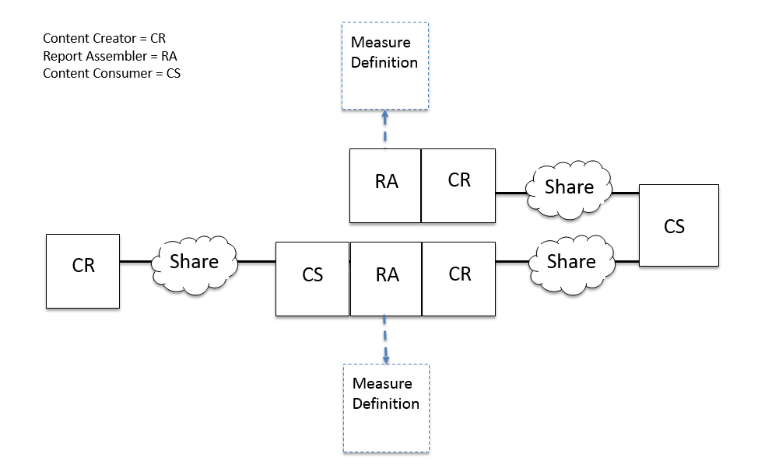

Figure X.1-1: Quality Measure Execution-Early Hearing Actor Diagram

Note: A system that implements the Content Consumer actor on the right side of the Actor Diagram could also implement the Content Creator actor, shown on the left side of the Actor Diagram. Similarly, system that implements the Content Creator actor on the left side of the Actor Diagram could also implement the Content Consumer actor, shown on the right side of the Actor Diagram. When this “dual role” pattern is implemented, the systems that implement both the Content Consumer and Content Creator actors would be positioned to share quality measure report documents back “upstream” to create a close loop for information sharing.

Table X.1-1: QME-EH - Actors and Content Modules

| Actors | Content Modules  (Note 1) | Optionality | Reference |
| --- | --- | --- | --- |
| Report Assembler | EHDI Measure Definition (eCQM EDHI) | R | QRPH TF-4:X.1.1.1 |
| Content Consumer  (Note 2) | Summary of Care Document  (SoCD) | O | QRPH TF-4:X.1.1.2 |
| Aggregate-Level Quality Report  (ALQR) | O | QRPH TF-4: X.1.1.2 |
| Patient-Level Quality Report  (PLQR) | O | QRPH TF-4: X.1.1.2 |
| Content Creator  (Note 2) | Summary of Care Document (SoCD) | O | QRPH TF – 1:X.1.1.3 |
| Aggregate-Level Quality Report  (ALQR) | O | QRPH TF – 1:X.1.1.3 |
| Patient-Level Quality Report  (PLQR) | O | QRPH TF – 1:X.1.1.3 |

Note 1: These generalized content modules need to be defined specifically at the realm level for specific implementations. Bindings of these content modules are defined in Volume 4.

Note 2: See specific Actor Options and Grouping for further details on content module requirements.

### X.1.1 Actor Descriptions and Actor Profile Requirements

#### X.1.1.1 Report Assembler

A system implementing the Report Assembler actor consumes the definition of the quality measure. (This specification does not place requirements on how the measure’s definition is consumed.) The Report Assembler implements the data element processing, logic criteria assessment capabilities, and computational functionality required to execute the defined Newborn Hearing Screening quality measure.

A system implementing the Report Assembler actor SHALL implement one or more of the following options: the Assemble Aggregate-Level Quality Report (Assemble ALQR) option, the Assemble Patient-Level Quality Report (Assemble PLQR) option, the Assemble Patient-Level Quality Report from Summary of Care Document (Assemble PLQR from SoCD) option, or the Assemble Aggregate-Level Quality Report from Patient-Level Quality Report (Assemble ALQR from PLQR) option.

When implementing the Assemble ALQR option, the Report Assembler SHALL implement a Content Creator with the ALQR option. It SHALL create valid aggregate-level quality reports (ALQR) as defined for this eCQM.

When implementing the Assemble PLQR option, the Report Assembler SHALL implement a Content Creator with the PLQR option. It SHALL create valid patient-level quality reports (PLQR) as defined for this eCQM.

When implementing the Assemble PLQR from SoCD option, the Report Assembler SHALL implement a Content Consumer which supports consumption of a Summary of Care Document and SHALL implement the PCC Content Consumer Discrete Data Import option. The Report Assemler also SHALL implement a Content Creater with the PLQR option. For the run of SoCDs provided for processing, it SHALL create a corresponding set of valid patient-level quality report (PLQR) documents as defined for this eCQM. The mechanism for establishing the set of SoCD documents to be consumed is outside the scope of this specification. For each summary of care document matching the criteria for the initial patient population in the measure definition, the Report Assembler SHALL create a set of valid patient-level quality report (PLQR) documents by utilizing the realm-assigned document types for the SoCD and PLQR documents and applying the derivation rules defined at the realm level for this eCQM.

When implementing the Assemble ALQR from PLQR option, the Report Assembler SHALL implement a Content Consumer with the PLQR option and it SHALL implement the PCC Content Consumer Discrete Data Import option. The Report Assembler also SHALL implement a Content Creater with the ALQR option. For the run of PLQRs provided for processing, it SHALL create a valid aggregate-level quality report (ALQR) as defined for this eCQM. The mechanism for establishing the set of PLQR documents to be consumed is outside the scope of this specification. For the provided set of patient-level quality report documents, matching the criteria for the initial patient population measure definition for the measure, the Report Assembler SHALL create a valid Aggregate-level quality report (ALQR) by utilizing the realm-assigned document types for the ALQR and PLQR documents and applying the derivation rules defined at the realm level for this eCQM.

The Report Assembler MAY implement an exception reporting function. The exception report may documenting data element processing errors detected while processing incoming documents. For example, when a data element in the patient-level quality report specified by this profile cannot be populated, this would be reported as an exception. Formatting of the exception information is not specified by this profile. The report MAY include information such as an identifier for the SoCD and the data elements that could not be populated in the corresponding patient-level quality report.

#### X.1.1.2 Content Consumer

A system implementing the Content Consumer actor SHALL conform to requirements specified for the Content Consumer actor in the PCC Technical Framework and SHALL implement the View option.

A system implementing the Content Consumer actor SHALL implement the PLQR or ALQR options and MAY implement both.

When implementing the Consume PLQR option, the Content Consumer SHALL consume valid PLQR documents.

When implementing the Consume ALQR option, the Content Consumer SHALL consume valid ALQR documents.

#### X.1.1.3 Content Creator

The Content Creator SHALL conform to requirements specified for the Content Creator actor in the PCC Technical Framework.

When implementing the SoCD option, the Content Creator SHALL create valid Summary of Care Document (SoCD).

## X.2 Actor Options

Table X.2-1: QME-EH – Actors and Options

| Actor | Option Name | Reference  *<either reference TF-3 or the applicable X.2.x subsection below table>* |
| --- | --- | --- |
| Report Assembler (Note 1) | Assemble ALQR | QRPH TF – 1:X.1.2.1 |
| Assemble PLQR | QRPH TF – 1:X.1.2.2 |
| Assemble PLQR from SoCD | QRPH TF – 1:X.1.2.3 |
| Assemble ALQR from PLQR | QRPH TF – 1:X.1.2.4 |
| Content Consumer (Note 2) | Consume ALQR | QRPH TF – 1:X.1.2.5 |
| Consume PLQR | QRPH TF – 1:X.1.2.6 |
| Content Creator (Note 3) | Create SoCD | QRPH TF – 1:X.1.2.7 |

Note 1: A system implementing the Report Assembler actor SHALL implement one or more of the following options: Assemble ALQR, Assemble PLQR option, Assemble PLQR from SoCD option, or the Assemble ALQR from PLQR option.

Note 2: Systems implementing the Assemble PLQR from SoCD option are grouped with a Content Consumer of SoCD documents. This Actor Option needs to be implemented by systems implementing the Report Assembler actor when demonstrating the Assemble PLQR from SoCD option. The Content Consumer with the SoCD option is not a standalone actor option in this profile.

Note 3: Systems implementing the Assemble PLQR or Assemble PLQR from SoCD option are grouped with a Content Creator of PLQR documents. The Content Creator with the PLQR option is not a standalone actor option in this profile. Systems implementing the Assemble ALQR or Assemble ALQR from PLQR option are grouped with a Content Creator of ALQR documents. The Content Creator with the ALQR option is not a standalone actor option in this profile.

### X.2.1 Assemble ALQR Option

A system implementing the Assemble ALQR option SHALL create a valid aggregate-level quality report document according to this measure’s definition.

A system implementing the Assemble ALQR option SHALL create and share valid aggregate-level quality report documents.

### X.2.2 Assemble PLQR Option

A system implementing the Assemble PLQR option SHALL create a valid patient-level quality report document according to this measure’s definition.

A Content Creator implementing the PLQR option SHALL create and share valid patient-level quality report documents.

### X.2.3 Assemble ALQR from PLQR Option

A system implementing the Assemble ALQR from PLQR option SHALL access and consume valid patient-level quality report documents with View and Discrete Data Import options.

A system implementing the Assemble ALQR from PLQR option SHALL consume one or more valid PLQR documents for the Newborn Hearing Screening measure and create a valid aggregate-level quality report according to this measure’s definition.

A system implementing the Assemble ALQR from PLQR option SHALL create and share valid aggregate-level quality report documents.

### X.2.4 Assemble PLQR from SoCD Option

A system implementing the Assemble PLQR from SoCD option SHALL access and consume valid Summary of Care documents with View and Discrete Data Import options.

A system implementing the Assemble PLQR from SoCD option SHALL consume one or more valid SoCDs for the Newborn Hearing Screening measure and create a valid patient-level quality report according to this measure’s definition.

A system implementing the Assemble PLQR from SoCD option SHALL create and share valid patient-level quality report documents.

### X.2.5 Consume ALQR Option

A system implementing the ALQR option SHALL access and consume valid aggregate-level quality report documents with View option.

### X.2.6 Consume PLQR Option

A system implementing the PLQR option SHALL access and consume valid patient-level quality report documents with View and Discrete Data Import options.

### X.2.7 Create SoCD Option

A system implementing the SoCD option SHALL create and share valid summary of care documents.

## X.3 Required Actor Groupings

| <this Profile Acronym> Actor | Actor to be grouped with | Reference | Content Bindings Reference |
| --- | --- | --- | --- |
| Report Assembler with  Assemble ALQR Option | Content Creator (ALQR option) | This grouping supports Use Case #1  QRPH TF – 1:X.4.2.1 | QRPH TF – 1:X.2.1 |
| Report Assembler with Assemble PLQR Option | Content Creator (PLQR option) | This grouping supports Use Case #2  QRPH TF – 1:X.4.2.2 | QRPH TF – 1:X.2.10 |
| Report Assembler with Assemble PLQR from SoCD Option | Content Consumer (SoCD option)  Content Creator (PLQR Option) | This grouping supports Use Case #3 and Use Case #4  QRPH TF – 1:X.4.2.3  QRPH TF – 1:X.4.2.4 | QRPH TF – 1:X.2.8  QRPH TF – 1:X.2.10 |
| Report Assembler with  Assemble ALQR from PLQR Option | Content Consumer (PLQR option)  Content Creator (ALQR option) | This grouping supports Use Case #4  QRPH TF – 1:X.4.2.4 | QRPH TF – 1:X.2.7  QRPH TF – 1:X.2.9 |

Note: Use Case #4 shows how a system at the information flow, playing the role of a Content Consumer with ALQR option or Content Consumer with PLQR option, can turn around and play the role of the Report Assembler with Assemble ALQR option. The “role reversal” is used to close the information loop by enabling the system that creates the aggregate-level report to share it back with a system that may have provided data used in the aggregate-level report. This type of information “back channel” can be shown by putting the ALQR information consumer in role of Report Assembler with Assemble ALQR option and then putting the system to receive the information in the Content Consumer (ALQR option).

## X.4 Overview

### X.4.1 Concepts

### X.4.2 Use Cases

#### X.4.2.1 Use Case #1: Low Transparency for Receivers, High Burden for Senders

A Birthing facility participates in a quality measurement program that assesses the quality of the process used to perform hearing screening for newborns. The facility employs a system capable of producing an aggregate-level quality report for the Newborn Hearing Screening measure (EHDI eCQM) defined by the program. The system assembles the final aggregate-level quality report based on data available in the system. It shares the report so that an organization, such as CMS or a Public Health Agency, can access the information. No patient-level information is supplied to support validation of the computation used to generate the aggregate report or to provide patient-level insight information that might be used to do risk adjustment.

##### X.4.2.1.1 Use Case Description

A system that includes functionality to compute the EHDI eCQM produces a valid aggregate-level report for the Newborn Hearing Screening measure and supplies it for consumption. The shared aggregate-level report is consumed by another system.

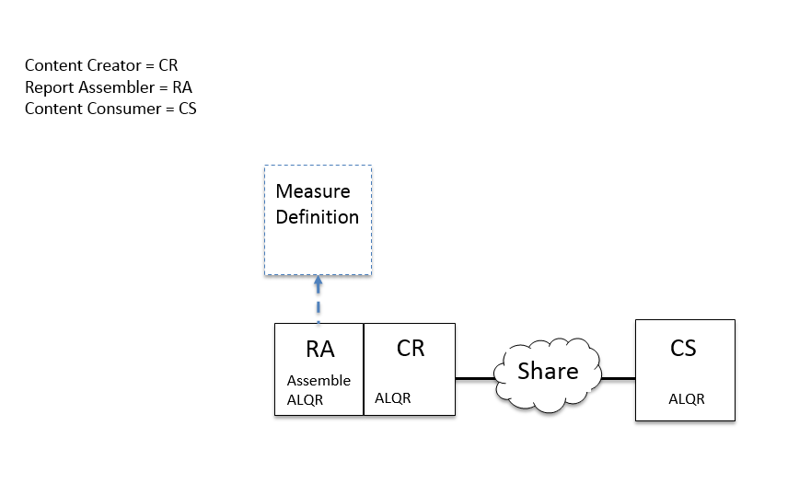

###### X.4.2.1.1.1 Pre-conditions

None.

###### X.4.2.1.1.2 Main Flow

A Birthing facility participates in a quality measurement program that assesses the quality of the process used to perform hearing screening for newborns. The facility employs a system capable of producing an aggregate-level quality report for the Newborn Hearing Screening measure (EHDI eCQM) defined by the program.

Based on the EHDI eCQM definition, a system uses internally defined methods and internally available data to generate an aggregate-level quality report for the EHDI eCQM.

Another system accesses the aggregate-level quality report and processes it. The receiving system is operated by an organization like CMS or a Public Health Agency.

###### X.4.2.1.1.3 Post-conditions

The organization accessing the aggregate-level report receives the measure performance result, but gains no insight about patient-level information aggregated in the report. Consequently, the receiving system cannot validate the computation used to generate the report. Nor can it compute any risk adjustments for the result. Results reported from different facilities may be based on data extraction and computation practices that are not consistent.

##### X.4.2.1.2 Processing Steps

Step 1 – A system produces an aggregate-level quality report document that is the EHDI eCQM and shares the document.

Step 2 – Another system accesses the EHDI eCQM aggregate-level quality report and consumes it for processing.

##### X.4.2.1.3 Process Flow

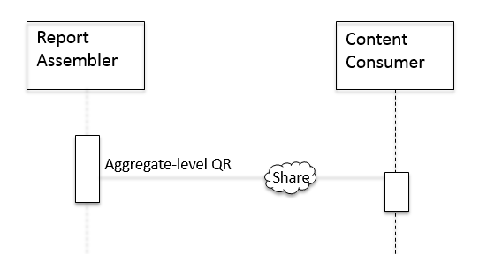

Figure X.4.2.1-1: Process Flow Diagram

#### X.4.2.2 Use Case #2: Better Transparency for Receivers, But Similar Burden for Senders

A Birthing facility participates in a quality measurement program that assesses the quality of the process used to perform hearing screening for newborns. The facility employs a system capable of producing patient-level quality reports for the Newborn Hearing Screening measure (EHDI eCQM) defined by the program. The system assembles patient-level quality reports based on data available in the system. It shares the reports so that organizations, such as CMS, Public Health Agencies, companies that offer quality measure services, can access the information. Patient-level information is supplied to support validation of the computation used to generate the aggregate report or to provide patient-level insight information that might be used to do risk adjustment.

##### X.4.2.2.1 Use Case Description

A system that includes functionality to compute the EHDI eCQM produces valid patient-level reports for the Newborn Hearing Screening measure and supplies them for consumption. The shared patient-level reports are consumed by another system.

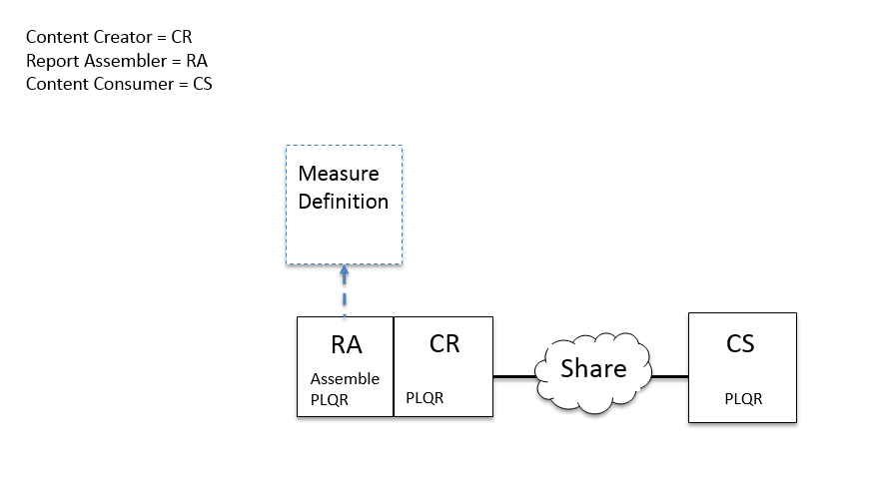

###### X.4.2.2.1.1 Pre-conditions

None.

###### X.4.2.2.1.2 Main Flow

A Birthing facility participates in a quality measurement program that assesses the quality of the process used to perform hearing screening for newborns. The facility employs a system capable of producing a patient-level quality reports for the Newborn Hearing Screening measure (EHDI eCQM) defined by the program.

Based on the EHDI eCQM definition, a system uses internally defined methods and internally available data to generate patient-level quality reports for the EHDI eCQM.

Another system accesses the patient-level quality reports and processes them. The receiving system is operated by an organization like CMS or a Public Health Agency or an organization that provides quality measure services. The receiving system assembles the patient-level reports and shares them for subsequent processing.

###### X.4.2.2.1.3 Post-conditions

The organization accessing the patient-level reports receives data that can be used to compute measure performance result. Consequently, the receiving system can compute the measure result using their own methods. Risk adjustments can be applied and are transparent for the receiving organization. Although data extraction practices may vary across organizations submitting the patient-level reports, performance results can be computed consistently across different facilities.

##### X.4.2.2.2 Processing Steps

Step 1 – A system produces patient-level quality report documents for the EHDI eCQM and shares the documents.

Step 2 – Another system accesses the EHDI eCQM patient-level quality report documents and consumes them for processing.

##### X.4.2.2.3 Process Flow

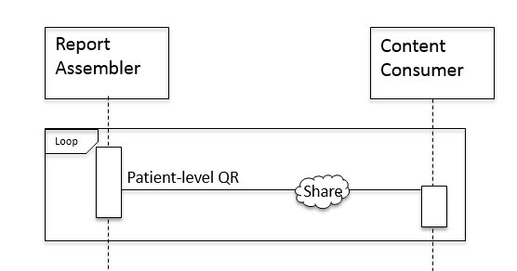

Figure X.4.2.2-1: Process Flow Diagram

#### X.4.2.3 Use Case #3: Less Burden For Senders AND Better Transparency For Receivers

A Birthing facility participates in a quality measurement program that assesses the quality of the process used to perform hearing screening for newborns. The facility does not employ a system that is capable of producing aggregate- or patient-level quality reports for the Newborn Hearing Screening measure (EHDI eCQM) defined by the program. The system creates summary of care documents based on data available in the system to facilitate continuity of care. It shares the documents with other organizations to facilitate continuity of care and support business options.

Information available in the summary of care document is processed to produce the patient-level quality reports. The receiving system assembles the patient-level reports and shares them for subsequent processing.

The system may produce an exception report as it produces the patient-level quality reports. The exception report can be used to create a feedback loop to improve the quality of the data in the care summary records being produced by the birthing facility.

##### X.4.2.3.1 Use Case Description

A system that does not includes functionality to create aggregate- or patient-level quality report documents for the EHDI eCQM produces and shares valid summary of care documents. The shared summary of care documents are consumed by another system. The second system assembles and shares patient-level quality report documents based on the EHDI eCQM definition. The system uses internally defined methods to generate patient-level quality reports for the EHDI eCQM using data provided in the summary of care documents.

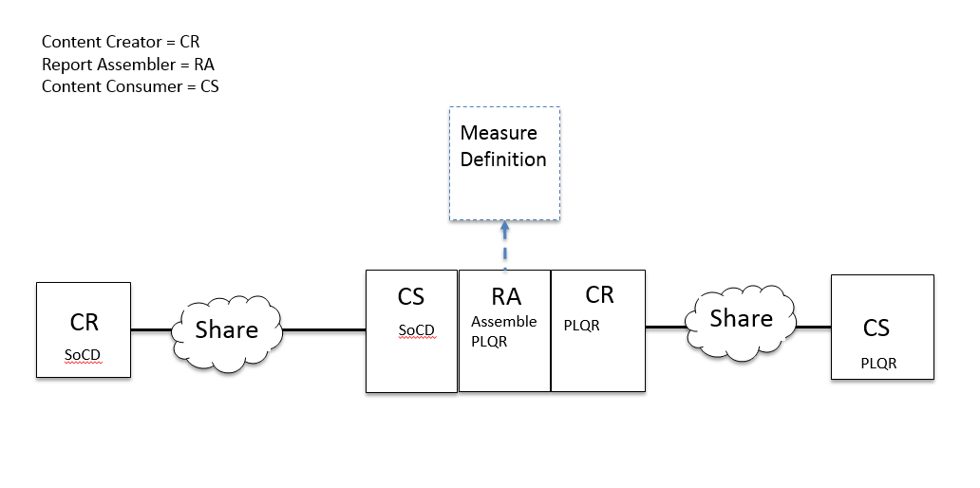

###### X.4.2.3.1.1 Pre-conditions

None.

###### X.4.2.3.1.2 Main Flow

A Birthing facility participates in a quality measurement program that assesses the quality of the process used to perform hearing screening for newborns. The facility does not employ a system capable of producing aggregate- or patient-level quality reports for the Newborn Hearing Screening measure (EHDI eCQM) defined by the program. The facility produces and shares summary of care documents to support continuity of care and business operations.

Another system accesses the summary of care documents and processes them. The receiving system is operated by an organization that provides quality measure services, or a Public Health organization. Based on the EHDI eCQM definition, the system uses internally defined methods to generate patient-level quality reports for the data supplied in the summary of care documents. The patient-level quality reports are shared for subsequent processing.

###### X.4.2.3.1.3 Post-conditions

In this use case, the birthing facility reporting the Newborn Hearing Screening measure does not produce any quality reports. The birthing facility simply focuses on producing high quality interoperable clinical summary of care documents for each newborn.

The organization receiving the summary of care documents is responsible for computing the measured performance result. The organization gains insight into the summary of care data and the patient-level information used to compute the measure, but no aggregate-level report is generated. Computation of the aggregate-level report remains a processing step that would still need to be addressed.

##### X.4.2.3.2 Processing Steps

Step 1 – A system produces summary of care document for the newborn in support of continuity of care.

Step 2 – Another system accesses the summary of care documents and assembles the EHDI eCQM patient-level quality report documents. The patient-level quality report documents are shared for subsequent processing.

Step 3 – The system that produces the patient-level quality report documents may produce an exception report which describes processing problems for care summary reports.

Step 4 - The patient-level quality reports are accessed by a system that processes the documents.

##### X.4.2.3.3 Process Flow

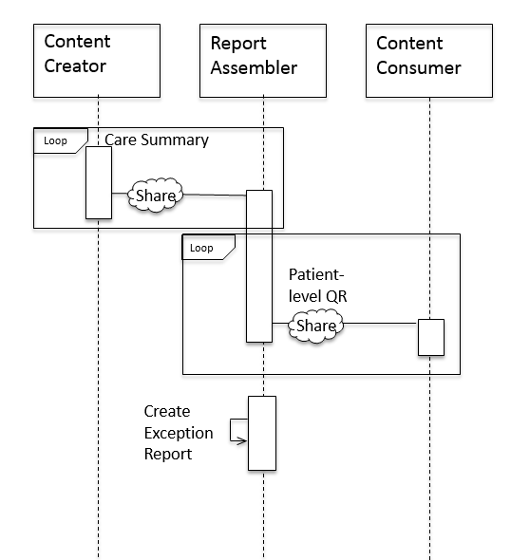

Figure X.4.2.3-1: Process Flow Diagram

#### X.4.2.4 Use Case #4: Less Burden for Senders AND Receivers

A Birthing facility participates in a quality measurement program that assesses the quality of the process used to perform hearing screening for newborns. The facility does not employ a system that is capable of producing aggregate- or patient-level quality reports for the Newborn Hearing Screening measure (EHDI eCQM) defined by the program. The system creates summary of care documents based on data available in the system to facilitate continuity of care. It shares the documents with other organizations to facilitate continuity of care and support business options.

Information available in the summary of care document is processed to produce the patient-level quality reports. The receiving system assembles the patient-level reports and shares them for subsequent processing.

Once the patient-level reports are shared, a system capable of producing aggregate-level quality reports for the Newborn Hearing Screening measure (EHDI eCQM) defined by the program consumes the documents and creates the aggregate-level quality report document. The document is shared for subsequent processing.

##### X.4.2.4.1 Use Case Description

A system that does not includes functionality to create aggregate- or patient-level quality report documents for the EHDI eCQM produces and shares valid summary of care documents. The shared summary of care documents are consumed by another system. The second system assembles and shares patient-level quality report documents based on the EHDI eCQM definition. The system uses internally defined methods to generate patient-level quality reports for the EHDI eCQM using data provided in the summary of care documents. A system capable of producing aggregate-level quality reports for the Newborn Hearing Screening measure (EHDI eCQM) defined by the program consumes the patient-level quality report documents, then creates and shares the aggregate-level quality report document with CMS or Public Health. As an alternate flow, the aggregate-level quality report is shared with the organization participating in the program.

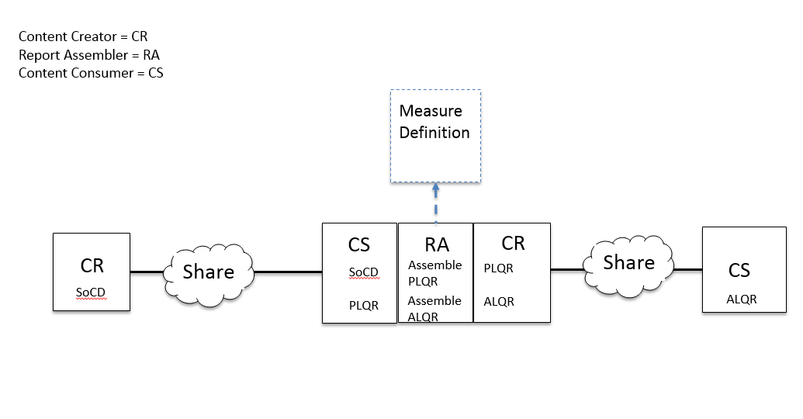

Alternate diagram showing systems implementing a different combination of actor roles from this profile.

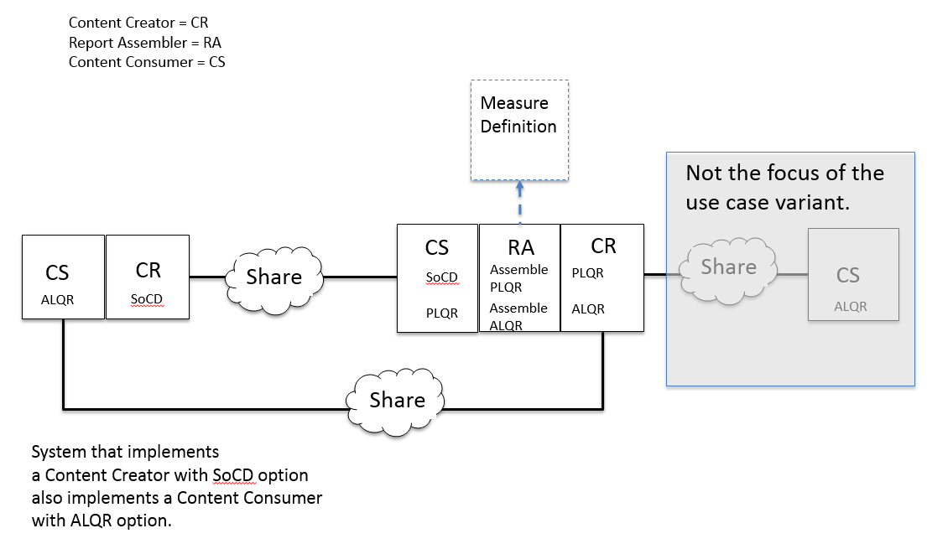

###### X.4.2.4.1.1 Pre-conditions

None.

###### X.4.2.4.1.2 Main Flow

The Birthing facility participating in the quality measurement program does not need to employ a system capable of producing quality reports. It simply produces the summary of care documents required to support continuity of care. This system acts as the Content Creator.

The Quality Report Assembler extracts data available in the care summary and transforms it to meet the requirements of the patient-level quality measure report. While processing the data, the Quality Report Assembler may produce a report which details and summarizes any problems with the data provided in the care summary reports. The set of patient-level reports are then processed to and a single aggregate-level quality report is created. The aggregate-level report is shared with an organization such as CMS or a Public Health agency which receives performance measure information.

The receiving organization is not responsible for computing the performance result for the quality measure. This system only needs to process aggregate-level quality reports.

###### X.4.2.4.1.3 Post-conditions

In this use case, the birthing facility reporting the Newborn Hearing Screening measure does not produce any quality reports. The birthing facility simply focuses on producing high quality interoperable clinical summary of care documents for each newborn.

The organization receiving the summary of care documents is responsible for computing the measured performance result. The organization gains insight into the summary of care data and the patient-level information used to compute the measure, but no aggregate-level report is generated. Computation is performed for the aggregate-level report document and the information is shared. This can be used to deliver a completed aggregate-level report to the quality program. The aggregate-level report also can be shared with facilities that participate in the program.

##### X.4.2.4.2 Processing Steps

Step 1 – A system produces summary of care document for the newborn in support of continuity of care.

Step 2 – Another system accesses the summary of care documents and assembles the EHDI eCQM patient-level quality report documents. The patient-level quality report documents are created and shared for subsequent processing. (Note: This profile does not include specific requirements for where the created documents are stored for subsequent access, i.e. shared.)

Step 3 – The system that produces the patient-level quality report documents may produce an exception report which describes processing problems for care summary reports.

Step 4 - The patient-level quality report documents are accessed by a system that processes the documents. (In this use case it is the same system that produced and shared the patient-level quality reports.)

Step 5 – Access the patient-level quality report documents to create the EHDI eCQM aggregate -level quality report document. The aggregate-level quality report document is shared for subsequent access.

Step 6 – Access the aggregate-level quality report document. (Note: access can be from any system that implements the Content Consumer with the ALQR option. This profile does not include specific requirements for how sharing is achieved.)

##### X.4.2.4.3 Process Flow

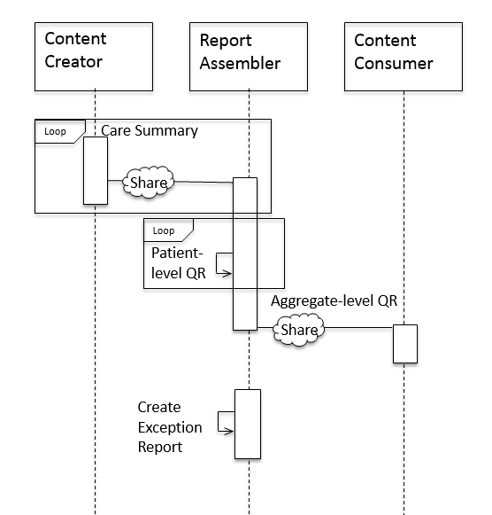

Figure X.4.2.4-1: Process Flow Diagram

#### X.4.2.5 Use Case #5: Less Burden for Senders AND Standards-based Processing for Receivers

In this use case, the birthing facility reporting the Newborn Hearing Screening measure does not produce any quality reports. The birthing facility simply focuses on producing high quality interoperable clinical summary of care documents for each newborn. Information available in the summary of care document is then processed to produce the patient-level quality reports. The system that produces the patient-level quality reports may provide an error report to create a feedback loop about changes that would improve the quality of the care summary records being produced by the birthing facility. The receiving organization, such as CMS or a Public Health agency, consumes the patient-level quality reports and produces an aggregate-level quality report which can be validated against the set of patient-level reports. Finally, the aggregate-level quality report is shared with the organization participating in the program.

##### X.4.2.5.1 Use Case Description

The Content Creator produces a standard care summary for the Newborn. The Quality Report Assembler processes the information in the care summaries to produce patient-level quality reports as required by the Newborn Hearing Screening measure. The Content Consumer processes the patient-level reports and produces the aggregate-level report. The Quality Report Assembler may produce a report that details and summarizes processing problems in the care summaries produced by the Content Creator.

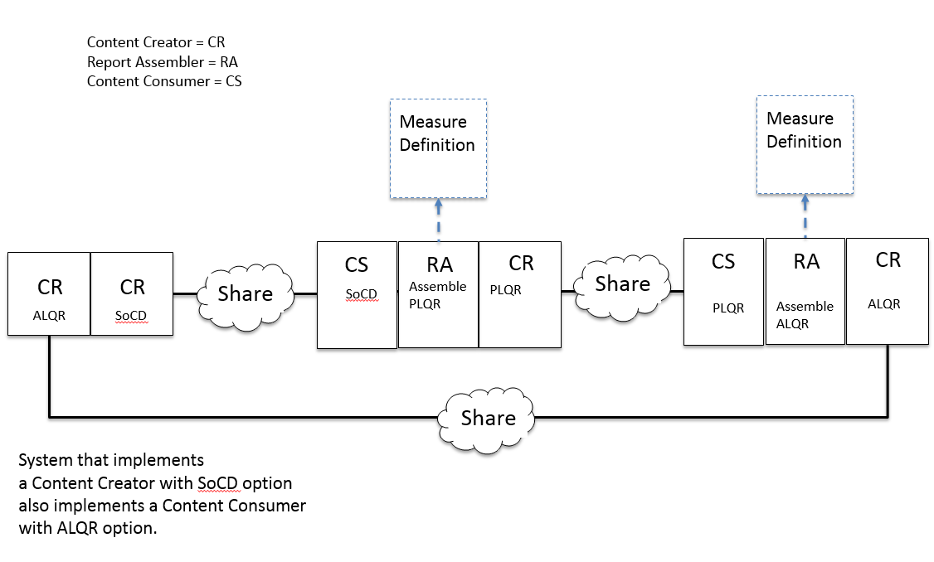

###### X.4.2.5.1.1 Pre-conditions

None.

###### X.4.2.5.1.2 Main Flow

The Birthing facility participating in the quality measurement program does not need to employ a system capable of producing quality reports. It simply produces the summary of care documents required to support continuity of care. This system acts as the Content Creator.

The Quality Report Assembler extracts data available in the care summary and transforms it to meet the requirements of the patient-level quality measure report. While processing the data, the Quality Report Assembler may produce a report which details and summarizes any problems with the data provided in the care summary reports.

The Content Consumer processes the set of patient-level reports and creates a single aggregate-level quality report.

###### X.4.2.5.1.3 Post-conditions

The receiving organization receives the patient-level information measured for the report and performs the standard specified computation for the measure. This permits the performance measure computation to be validated as a full end-to-end standard supported by the receiving organization.

##### X.4.2.5.2 Processing Steps

Step 1 – A system produces summary of care document for the newborn in support of continuity of care.

Step 2 – Another system accesses the summary of care documents and assembles the EHDI eCQM patient-level quality report documents. The patient-level quality report documents are shared for subsequent processing.

Step 3 – The system that produces the patient-level quality report documents may produce an exception report which describes processing problems for care summary reports.

Step 4 - The patient-level quality report documents are accessed by a system that processes the documents. (In this use case it is a different system than the system with produced and shared the patient-level quality reports.)

Step 5 – Access the patient-level quality report documents to create the EHDI eCQM aggregate -level quality report document. The aggregate-level quality report document is shared for subsequent access.

Step 6 – Access the aggregate-level quality report document.

##### X.4.2.5.3 Process Flow

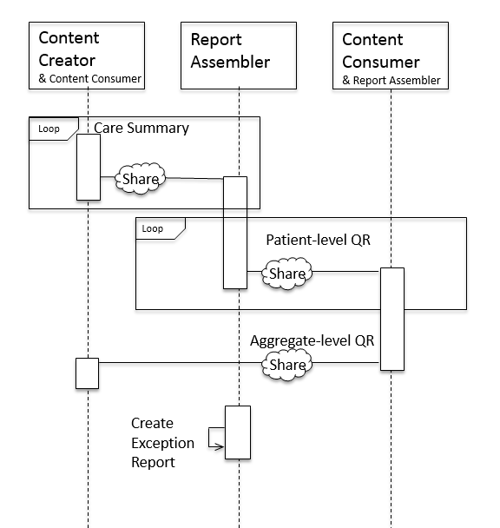

Figure X.4.2.5-1: Process Flow Diagram

Note: In the last step, the System playing the Content Consumer is grouped with a Report Assembler that is grouped with a Content Creator.

## X.5 Security Considerations

Patient-level quality report and summary of care documents includes clinical content related to the information subject. As such, it is anticipated that the transfers of Protected Health Information (PHI) SHOULD be processed using best practices. Systems implementing IHE transactions which transfer PHI SHOULD include capabilities described in the IHE ITI ATNA Integration Profile. Other private security mechanisms MAY be used to secure content within enterprise managed systems. Specifications for ATNA logging for RFD transactions are covered in QRPH CRD TF 2:5.

Actors responsible for creating persistent content, in the form of a saved form or CDA document, MAY include a digital signature using ITI DSG to assure that the form content submitted cannot be changed.

For security purposes, when sending information to Public Health, specifically to vital records Electronic Registration Systems, systems will also may need to know the identity of the user and the location to identify the of the data source. In this case, XUA and ATNA MAY be utilized to support this implementation.

## X.6 Cross Profile Considerations

The following informative narrative is offered as implementation guidance.

### X.6.1 Cross Enterprise Document Sharing (XDS.b), Cross Enterprise Document Media Interchange (XDM), or Cross Enterprise Document Reliable Interchange (XDR)

The use of the IHE family of transactions for cross-enterprise document sharing is encouraged to support standards-based interoperability between systems acting as Content Creator and Content Consumer. The grouping of Content Creator and Content Consumer actors with ITI actors from this family of profiles is defined in the PCC Technical Framework (PCC TF 1:3.7.1). Below is a summary of recommended IHE transport transactions that MAY be utilized by systems playing the roles of Content Creator or Content Consumer to support the use cases defined in this profile:

* A Document Source in XDS.b, a Portable Media Creator in XDM, or a Document Source in XDR might be grouped with the Content Creator. A Document Consumer in XDS.b, a Portable Media Importer in XDM, or a Document Recipient in XDR might be grouped with the HPoC Content Consumer. A registry/repository-based infrastructure is defined by the IHE Cross Enterprise Document Sharing (XDS.b) that includes profile support that can be leveraged to facilitate retrieval of public health related information from a document sharing infrastructure: Multi-Patient Query (MPQ), Document Metadata Subscription (DSUB) and notification of availability of documents (NAV),
* A media-based infrastructure is defined by the IHE Cross Enterprise Document Media Interchange (XDM) Profile. A Portable Media Creator in XDM might be grouped with the Content Creator. A Portable Media Importer in XDM might be grouped with the Content Consumer,
* A reliable messaging-based infrastructure is defined by the IHE Cross Enterprise Document Reliable Interchange (XDR) Profile. Document Source in XDR might be grouped with the Content Creator. A Document Recipient in XDR might be grouped with the Content Consumer,
* All of these infrastructures support security and privacy through the use of the Consistent Time (CT) and Audit Trail and Node Authentication (ATNA) profiles. A Time Client in CT might be grouped with the Content Creator and the Content Consumer. A Secure Node and/or a Secure Application in ATNA might be grouped with the Content Creator and the Content Consumer.

Detailed description of these transactions can be found in the IHE IT Infrastructure Technical Framework.

### X.6.2 Sharing Value Set (SVS)

Actors in the QME-EH Profile may support the ITI Sharing Value Set (SVS) Integration Profile in order to use a common uniform managed vocabulary for dynamic management of form mapping rules.

### X.6.3 Newborn Admission Notification Information (NANI)

Actors in the QME-EH Profile may support functionality defined in the Newborn Admission Notification Information profile in order to establish an expectation of the total number of births recorded at a hospital. This information can be used to determine if the run of documents processed for the quality measure is complete.

Appendices

<Add Appendices to this Profile here. Examples of an appendix include HITSP mapping to IHE Use Cases or long use case definitions.>

<Volume 1 Appendices are informational only. No “SHALL” language is allowed in a Volume 1 appendix.>

# Appendix A – New Actors

This appendix A includes the brief definitions of any new IHE Actors being defined for the first time in this profile.

## A.1 Brief Actor Definitions for New Actors

|  |  |
| --- | --- |
| Actor | Definition |
| Quality Report Assembler | This actor consumes standard CDA summary of care documents and creates standard Patient-level Quality Reports by re-using the available data. Optionally, the Quality Report Assembler consumes Patient-level Quality Reports and generates an Aggregate-level report for the quality measure. |

# Appendix B – New Transactions

Appendix B includes the brief definitions of any new IHE Transactions being defined for the first time in this profile.

## B.1Brief Transaction Definitions

No new transaction defined.

# Appendix C – Quality Measure Definitions

This appendix C includes the definitions of any Newborn Hearing Screening quality measures relevant for this profile. If one measure definition is included, it is recorded as A.1. If additional definitions are included for this same measure (ie an alternative definition for a proportional measure that assesses the quality of the process used to assure that all newborns receive hearing screening at birth), then other definitions would be added to A.2, A.3, etc.

## A.1 US Newborn Hearing Screening (EH_CMS31v4_NQF1354)

|  |  |
| --- | --- |
| Title | Description |
| Hearing Screening Prior To Hospital Discharge | This measure assesses the proportion of births that have been screened for hearing loss before hospital discharge. |

The measure definition is included with this profile as supplemental material. Note: that the current version of the measure may be located on the CMS website in the eCQM Library. <http://cms.gov/Regulations-and-Guidance/Legislation/EHRIncentivePrograms/eCQM_Library.html>

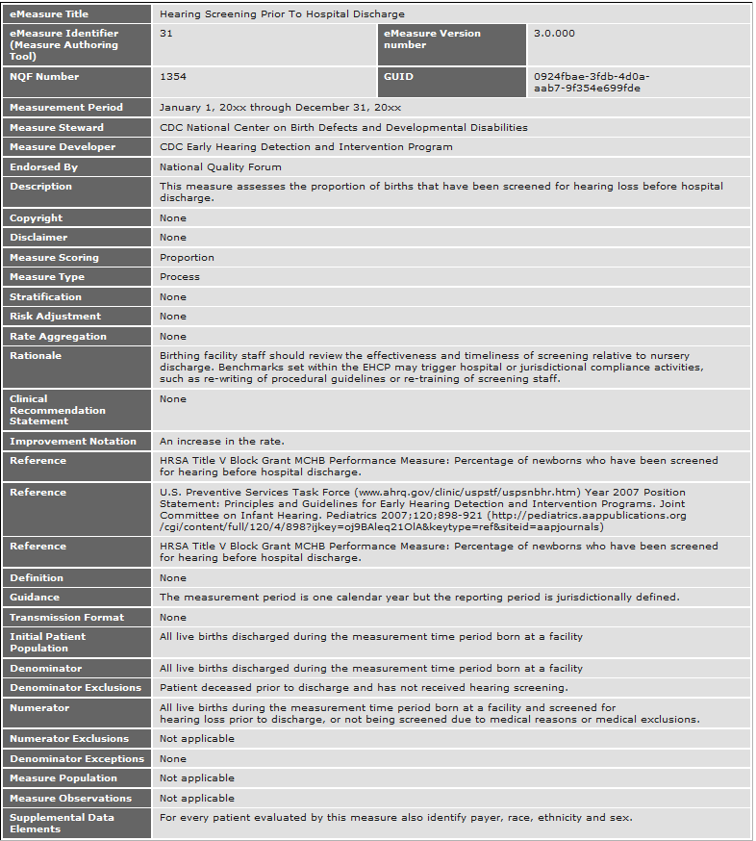

Population criteria

**Initial Patient Population =**

AND: "Occurrence A of Encounter, Performed: Encounter Inpatient" ends during "Measurement Period"

AND:

OR: "Diagnosis, Active: Liveborn Newborn Born in Hospital" starts during "Occurrence A of Encounter, Performed: Encounter Inpatient"

OR: "Diagnosis, Active: Livebirth" starts during "Occurrence A of Encounter, Performed: Encounter Inpatient"

**Denominator =**

AND: "Initial Patient Population"

**Denominator Exclusions =**

AND:

AND: "Patient Characteristic Expired: Patient Expired"

AND NOT:

OR: "Diagnostic Study, Result: Newborn Hearing Screen Left"

OR: "Diagnostic Study, Result: Newborn Hearing Screen Right"

during "Occurrence A of Encounter, Performed: Encounter Inpatient"

**Numerator =**

AND:

AND:

OR: "Diagnostic Study, Result: Newborn Hearing Screen Left (result: 'Pass Or Refer')"

OR: "Diagnostic Study, Result not done: Medical Reasons" for "Newborn Hearing Screen Left "

AND:

OR: "Diagnostic Study, Result: Newborn Hearing Screen Right (result: 'Pass Or Refer')"

OR: "Diagnostic Study, Result not done: Medical Reasons" for "Newborn Hearing Screen Right "

during "Occurrence A of Encounter, Performed: Encounter Inpatient"

**Denominator Exceptions =**

None

Data criteria (QDM Data Elements)

"Diagnosis, Active: Livebirth" using "Livebirth SNOMEDCT Value Set (2.16.840.1.114222.4.1.214079.1.1.1)"

"Diagnosis, Active: Liveborn Newborn Born in Hospital" using "Liveborn Newborn Born in Hospital Grouping Value Set (2.16.840.1.113762.1.4.1046.6)"

"Diagnostic Study, Result not done: Medical Reasons" using "Medical Reasons SNOMEDCT Value Set (2.16.840.1.114222.4.1.214079.1.1.7)"

"Diagnostic Study, Result not done: Medical Reasons" using "Medical Reasons SNOMEDCT Value Set (2.16.840.1.114222.4.1.214079.1.1.7)"

"Diagnostic Study, Result: Newborn Hearing Screen Left" using "Newborn Hearing Screen Left LOINC Value Set (2.16.840.1.114222.4.1.214079.1.1.3)"

"Diagnostic Study, Result: Newborn Hearing Screen Right" using "Newborn Hearing Screen Right LOINC Value Set (2.16.840.1.114222.4.1.214079.1.1.4)"

"Encounter, Performed: Encounter Inpatient" using "Encounter Inpatient SNOMEDCT Value Set (2.16.840.1.113883.3.666.5.307)"

"Patient Characteristic Expired: Patient Expired" using "Patient Expired SNOMEDCT Value Set (2.16.840.1.113883.3.117.1.7.1.309)"

Attribute: "Result: Pass Or Refer" using "Pass Or Refer SNOMEDCT Value Set (2.16.840.1.114222.4.1.214079.1.1.6)"

Reporting Stratification

None

Supplemental Data Elements

"Patient Characteristic Ethnicity: Ethnicity" using "Ethnicity CDCREC Value Set (2.16.840.1.114222.4.11.837)"

"Patient Characteristic Payer: Payer" using "Payer SOP Value Set (2.16.840.1.114222.4.11.3591)"

"Patient Characteristic Race: Race" using "Race CDCREC Value Set (2.16.840.1.114222.4.11.836)"

"Patient Characteristic Sex: ONC Administrative Sex" using "ONC Administrative Sex AdministrativeSex Value Set (2.16.840.1.113762.1.4.1)"

# Appendix D – Data Element Concepts

This appendix D defines a set of data element concepts in terms of a reference model. For each reference model referenced, a different table is established. For example, D.1 includes a the table which defines the data elements relevant to the Newborn Hearing Screening quality measure in terms of the NQF Quality Data Model (QDM) standard. If these data elements were defined in terms of the CDISC Object Data Model (ODM) standard, those definitions would be added in a different table found, perhaps, at D.2.

## D.1 Data Element Concepts

|  |  |  |
| --- | --- | --- |
| Concept Variable Name | Description | QDM Definition |
| $C_XXXX | The description of this element as it is used in the context of this quality measure. | QDM Category  QDM Datatype  QDM Attribute  Timing relationship  Value Set |
| $C_MEASUREPERIOD | The time interval applicable for the data collection. |  |
| $C_INPATIENT_ENCOUNTER | Data elements that meet criteria using this datatype should document that the encounter indicated by the QDM category and its corresponding value set has been completed. | Encounter  Encounter, Performed  Encounter Inpatient  Value Set:  Encounter Inpatient SNOMEDCT Value Set (2.16.840.1.113883.3.666.5.307) |
| $C_ETHNICITY | Data elements that meet criteria using this datatype should document that the patient has one or more of the ethnicities indicated by the QDM category and its corresponding value set. | Individual Characteristic  Patient Characteristic Ethnicity  Value Set:  Ethnicity CDCREC Value Set (2.16.840.1.114222.4.11.837) |
| $C_PAYER | Data elements that meet criteria using this datatype should document that the patient has one or more of the payers indicated by the QDM category and its corresponding value set | Individual Characteristic  Patient Characteristic Payer  Value Set:  Payer SOP Value Set (2.16.840.1.114222.4.11.3591) |
| $C_RACE | Data elements that meet criteria using this datatype should document the patient’s race. | Individual Characteristic  Patient Characteristic Race  Value Set:  Race CDCREC Value Set (2.16.840.1.114222.4.11.836) |
| $C_GENDER | Data elements that meet criteria using this datatype should document that the patient's sex matches the QDM category and its corresponding value set. | Individual Characteristic  Patient Characteristic Sex  Value Set:  ONC Administrative Sex AdministrativeSex Value Set (2.16.840.1.113762.1.4.1) |
| $C_LIVEBORN_IN_HOSPITAL | To meet criteria using this datatype, the diagnosis indicated by the Condition/Diagnosis/Problem QDM category and its corresponding value set should reflect documentation of an active diagnosis. Keep in mind that when this datatype is used with timing relationships, the criterion is looking for an active diagnosis for the time frame indicated by the timing relationships. | Condition/Diagnosis/Problem  Diagnosis, Active  Starts during "Occurrence A of Encounter, Performed: Encounter Inpatient"  Value set:  Liveborn Newborn Born in Hospital Grouping Value Set (2.16.840.1.113762.1.4.1046.6) |
| $C_LIVEBIRTH | To meet criteria using this datatype, the diagnosis indicated by the Condition/Diagnosis/Problem QDM category and its corresponding value set should reflect documentation of an active diagnosis. Keep in mind that when this datatype is used with timing relationships, the criterion is looking for an active diagnosis for the time frame indicated by the timing relationships. | Condition/Diagnosis/Problem  Diagnosis, Active  Starts during "Occurrence A of Encounter, Performed: Encounter Inpatient"  Value set:  Livebirth SNOMEDCT Value Set (2.16.840.1.114222.4.1.214079.1.1.1) |
| $C_EXPIRED | The *Patient Characteristic Expired* data element should document that the patient is deceased.  Note: *Patient Characteristic Expired* is fixed to SNOMED-CT® code 419099009 (Dead) and therefore cannot be further qualified with a value set. | Individual Characteristic  Patient Characteristic Expired  During "Occurrence A of Encounter, Performed: Encounter Inpatient"  Value set: see note.  Note: *Patient Characteristic Expired* is fixed to SNOMED-CT® code 419099009 (Dead) and therefore cannot be further qualified with a value set. |
| $C_LEFT_EAR_SCREENED | Data elements that meet criteria using this datatype should document the completion of the diagnostic study indicated by the QDM category and its corresponding value set. | Diagnostic Study  Diagnostic Study, Performed  Result (exists)  Newborn Hearing Screen Left  Value set:  Pass Or Refer SNOMEDCT Value Set (2.16.840.1.114222.4.1.214079.1.1.6)  Note: the result only needs to exist for this data element as it is evaluated here. The concept of PASS or REFER would be represented in different data elements. |
| $C_LEFT_EAR_NOT_SCREENED_REASON | Data elements that meet criteria using this datatype should document the completion of the diagnostic study indicated by the QDM category and its corresponding value set. | Diagnostic Study  Diagnostic Study, Performed  Reason  Value Set?  Medical Reasons SNOMEDCT Value Set (2.16.840.1.114222.4.1.214079.1.1.7) |
| $C_LEFT_EAR_NOT_SCREENED_NEGATION_RATIONALE | Data elements that meet criteria using this datatype should document the completion of the diagnostic study indicated by the QDM category and its corresponding value set. | Diagnostic Study  Diagnostic Study, Performed  Negation Rationale  Value Set?  Medical Reasons SNOMEDCT Value Set (2.16.840.1.114222.4.1.214079.1.1.7) |
| $C_LEFT_EAR_NOT_SCREENED_PATIENT_PREFERENCE | Data elements that meet criteria using this datatype should document the completion of the diagnostic study indicated by the QDM category and its corresponding value set. | Diagnostic Study  Diagnostic Study, Performed  Patient Preference  Value Set? |
| $C_LEFT_EAR_NOT_SCREENED_PHYSICIAN_PREFERENCE | Data elements that meet criteria using this datatype should document the completion of the diagnostic study indicated by the QDM category and its corresponding value set. | Diagnostic Study  Diagnostic Study, Performed  Physician Preference  Value Set? |
| $C_RIGHT_EAR_SCREENED | Data elements that meet criteria using this datatype should document the completion of the diagnostic study indicated by the QDM category and its corresponding value set. | Diagnostic Study  Diagnostic Study, Performed  Result (exists)  Newborn Hearing Screen Right  Value set:  Pass Or Refer SNOMEDCT Value Set (2.16.840.1.114222.4.1.214079.1.1.6)  Note: the result only needs to exist for this data element as it is evaluated here. The concept of PASS or REFER would be represented in different data elements. |
| $C_RIGHT_EAR_NOT_SCREENED_REASON | Data elements that meet criteria using this datatype should document the completion of the diagnostic study indicated by the QDM category and its corresponding value set. | Diagnostic Study  Diagnostic Study, Performed  Reason  Value Set?  Medical Reasons SNOMEDCT Value Set (2.16.840.1.114222.4.1.214079.1.1.7) |
| $C_RIGHT_EAR_NOT_SCREENED_NEGATION_RATIONALE | Data elements that meet criteria using this datatype should document the completion of the diagnostic study indicated by the QDM category and its corresponding value set. | Diagnostic Study  Diagnostic Study, Performed  Negation Rationale  Value Set?  Medical Reasons SNOMEDCT Value Set (2.16.840.1.114222.4.1.214079.1.1.7) |
| $C_RIGHT_EAR_NOT_SCREENED_PATIENT_PREFERENCE | Data elements that meet criteria using this datatype should document the completion of the diagnostic study indicated by the QDM category and its corresponding value set. | Diagnostic Study  Diagnostic Study, Performed  Patient Preference  Value Set? |
| $C_RIGHT_EAR_NOT_SCREENED_PHYSICIAN_PREFERENCE | Data elements that meet criteria using this datatype should document the completion of the diagnostic study indicated by the QDM category and its corresponding value set. | Diagnostic Study  Diagnostic Study, Performed  Physician Preference  Value Set? |

Volume 2 – Transactions

This profile does not create any new transactions.

It does not constrain or extend any previously defined transactions.

Volume 3 – UV Content Module Definitions

<The current version of the supplement template only addresses HL7 v3 CDA Content Modules. All CDA Content Modules will go in Section 6 of Volume 3 of each domain’s Technical Framework document. In the future, this supplement template may have additional sections for DICOM Content Modules (section 7 of Volume 3) and other types of Content Modules (section 8, etc., of Volume 3).

<Please note that prior to the release of the new template set, some domains may have defined CDA Content Modules in Volume 2 (e.g., PCC); however, going forward CDA Content Modules will be defined in Volume 3.>

# 5. Namespaces and Vocabularies

Add to section 5 Namespaces and Vocabularies

<Note that the code systems already defined in the Technical Framework of this domain may (but not required) be replicated here just to aid in the supplement review as a standalone document. Also note that the Section 5 table numbers and names are already defined in the TF Volume 3.>

| codeSystem | codeSystemName | Description |
| --- | --- | --- |
| <oid or uid> | <code system name> | <short description or pointer to more detailed description> |
| <oid or uid> | <code system name> | <short description or pointer to more detailed description> |
| <oid or uid> | <code system name> | <short description or pointer to more detailed description> |

Add to section 5.1.1 IHE Format Codes

| Profile | Format Code | Media Type | Template ID |
| --- | --- | --- | --- |
| <Profile name (profile acronym)> | <urn:ihe: > |  | <oids> |
|  |  |  |  |
|  |  |  |  |

Add to section 5.1.2 IHE ActCode Vocabulary

|  |  |
| --- | --- |
| Code | Description |
| <Code name> | <short one sentence description or reference to longer description (not preferred)> |
| <Code name> | <short one sentence description or reference to longer description (not preferred)> |
| <Code name> | <short one sentence description or reference to longer description (not preferred)> |

Add to section 5.1.3 IHE RoleCode Vocabulary

| Code | Description |
| --- | --- |
| <name of role> | <Short, one sentence description of role or reference to more info.> |
| <name of role> | <Short, one sentence description of role or reference to more info.> |
| <name of role> | <Short, one sentence description of role or reference to more info.> |

# 6. UV Realm Content Modules

## 6.3.1 CDA Document Content Modules

#### 6.3.1.Dx <Content Module Name (Acronym)> Document Content Module

##### 6.3.1.Dx.1 Format Code

##### 6.3.1.Dx.2 Parent Template(s)

##### 6.3.1.Dx.3 Referenced Standards

##### 6.3.1.Dx.4 Key Data Elements

## 6.3.2 CDA Header Content Modules

#### 6.3.2.Hx <Header Element Module Name> Header Content Module

## 6.3.3 CDA Section Content Modules

#### 6.3.3.Sx <Section Module Name> - Section Content Module

## 6.3.4 CDA Entry Content Modules

#### 6.3.4.Ex <Entry Content Module Name> Entry Content Module

## Section not applicable

This heading is not currently used when defining CDA templates.

## <Domain Acronym> Value Sets

### 6.5.Vx <Value Set Name> <oid>

## <Domain Acronym> Concept Domains

### 6.6.Cx <Concept Domain Name> <oid>

This defines, conceptually, the purpose of this Concept Domain.

It also establishes a default vocabulary binding for the Concept Domain which can be overridden by any realm-specific use of the template.

## <Domain Acronym> Derivation Rules

This section defines a derivation rules used for a particular purpose. The derivation rule set is used to create documents of one type from 1 or more documents of another type. The specific type of output document and the specific type(s) of input files are part of the definition of each named Derivation Rule Set.

### 6.7.Rx <Derivation Rule Set Name> Derivation Rule Set

This defines the Derivation Rule Set for a specific type of output artifact using a specific type of input artifact.

#### 6.7.Rx.1 <Data Element Name> Derivation Rule

This defines the derivation rule for the corresponding data element defined for this artifact. This artifact’s data elements are defined in section 6.3.1.Dx.4.

Appendices

Appendix A – Volume 3 Namespace Additions

Add the following terms to the IHE Namespace:

This is where I think we should document the creation of any sdtc extensions, or the creation of any ihe namespace additions.

<Please explicitly identify all new OIDs, UIDs, URNs, etc., defined specifically for this profile. These will be added to the IHE TF General Introduction namespace appendix when it becomes available. These items should be collected from the sections above by the author, and listed here as additions when this document is published for Trial Implementation. This section will be deleted prior to inclusion into the Technical Framework as Final Text, but should be present for publication of Public Comment and Trial Implementation.>

* 1. sdtc namespace

Appendix A.1 text goes here

A.2 ihe namespace

Appendix A.2 text goes here

Appendix B – <Appendix B Title>

Appendix B text goes here.

* 1. <Add Title>

Appendix B.1 text goes here.

Volume 4 – National Extensions

Add appropriate Country section

7 National Extensions

7.I1 US National Extension

<A template for Volume 4 is included in this document for completeness; however, National Extensions are typically developed after a profile has been published for Trial Implementation. If you are developing a new profile for Public Comment, it is recommended that this section be marked “Not Applicable”.>

<Avoid using this section if you can, this is “only if absolutely necessary”. Differences add cost to implementation and testing and can reduce interoperability. Review carefully to determine if the national use case truly requires a difference in the profile mechanisms rather than just differences in system configuration.>

< National Extensions can add requirements above and beyond IHE, but NOT relax requirements. This would prevent Connectathon results based on national testing being recognized elsewhere. For more information, see <http://wiki.ihe.net/index.php?title=National_Extensions_Process>.>

The format of this section is not strongly specified due to the varying nature of national extensions. For an example of National Extensions, see Radiology TF Volume 4.>

7.I1.1 Comment Submission

This national extension document was authored under the sponsorship and supervision of <sponsor name>, who welcome comments on this document and the IHE <country> initiative. Comments should be directed to:

<Name, organization, title, email address>

### 7.I1.2 US CDA Content Modules

#### 7.I1.2.D1 QME-EH Summary of Care Document Specification

*<This needs to be a table with the key metadata in it. The specific definition of a particular type of CDA document binds the concept of the “summary of care document” to an implementable type of document which is a standard for this particular realm.>*

##### 7.I1.2.D1.1 Document Body Constraints

*<Note: If no templateID is assigned to these further constraints, then the constraint is just implementer guidance. In order for a set of validation rules to be developed a unique template id must be assigned to the set of constraints expressed at this level.>*

##### 7.I1.2.D1.2 Header Content Module Constraints

*<Note: If no templateID is assigned to these further constraints, then the constraint is just implementer guidance. In order for a set of validation rules to be developed a unique template id must be assigned to the set of constraints expressed at this level.>*

##### 7.I1.2.D1.3 Section Content Modules Constraints

*<Note: If no templateID is assigned to these further constraints, then the constraint is just implementer guidance. In order for a set of validation rules to be developed a unique template id must be assigned to the set of constraints expressed at this level.>*

##### 7.I1.2.D1.4 Entry Content Modules Constraints

*<Note: If no templateID is assigned to these further constraints, then the constraint is just implementer guidance. In order for a set of validation rules to be developed a unique template id must be assigned to the set of constraints expressed at this level.>*

##### 7.I1.2.D1.5 Value Sets

##### 7.I1.2.D1.6 Concept Domain Bindings

##### 7.I1.2.D1.7 Data Element Derivation Rules

#### 7.I1.2.D2 QME-EH Patient-Level Quality Report Specification

#### 7.I1.2.D2 QME-EH Aggregate-Level Quality Report Specification

1. The first six documents are located on the IHE Website at http://www.ihe.net/Technical_Framework/index.cfm. The remaining documents can be obtained from their respective publishers.